People's Democratic Republic of Algeria
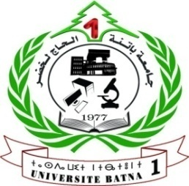
Ministry of Higher Education and Scientific Research
University of Batna 1 Hadj Lakhdar
Faculty of Humanities and Social Sciences
Department of Psychology, Educational Sciences and Orthophony
Laboratory of Psychological Applications in The punitive Environment
Closed-circuit Psychology Engineering Team
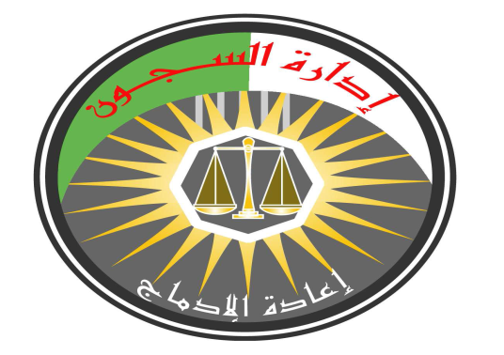
Organized

in cooperation with:
General Directorate of Prison Administration

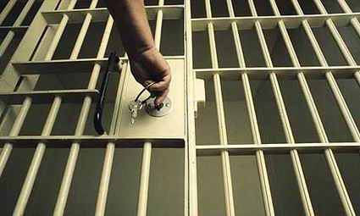
The First International Forum on:

Evaluate the Algerian experience in the field of the care and social reintegration of prisoners according to some international experiences

March 11^{h} and 12th, 2020

1 - Forum Problematic
The world has recently witnessed an increase in the crimes commission, and the multiplicity of its models, due to many factors, related to social and economic problems, especially with the increase of poverty, unemployment, social and family disintegration and others, as well as the result of mental disorders, which contribute significantly to the crimes commission of all kinds.
With the terrible increase in criminal acts and their consequences and effects on the individual and society, each country seeks to adopt a criminal and punitive policy to reduce this phenomenon, and perhaps the most important systems that contribute to face this phenomenon is the punitive system, which plays a large role in the care of deviant arrivals to these penal institutions for the purpose of rehabilitation and reintegration.
Many punitive systems have witnessed the development of the social reintegration to prisoners, especially those in countries that have adopted the ideas of Social Defense School, namely reform versus punishment, the result of this development is the international conventions that oblige each member country to humanize its penal institutions according to internationally adopted standards.
Algeria, like other countries, has initiated its reform of the penal system by introducing substantial amendments to the legislative and regulatory texts with a view to the full and comprehensive care of those imprisoned. The Algerian Prisons Regulation Act includes these reforms.
The efficacy of remedying the problems of delinquency and criminal relapse is one of the indicators that measure the effectiveness of punitive systems, especially those related to social reintegration policy and programs for this purpose. Algeria stepped very important steps in this regard, through its friction with some standard models in this field.
On this basis, the main problem of this forum is the evaluation of the Algerian experience compared to international experiences in the field of social reintegration to prisoners.

2 - Forum aims
The Forum seeks to assess the Algerian experience in the field of social reintegration to prisoners, by providing a chance to exchange of knowledge and ideas, and to review the experiences between researchers, specialists and decision makers, by achieving the following objectives:
- Presenting the Algerian experience in the field of the care and social reintegration to prisoners.
- Presenting examples of other countries experiences pioneer in the fields of the care and social reintegration to prisoners.
- Exchange the experiences between the university and the active institutions in the field.
- Providing a chance for professors, researchers and university students to friction and exchange of knowledge and experience.
3 - The targeted people of Forum:
• Research professors in national and international universities and various scientific research centers.
• Administrative and judicial staff of institutions related to the subject of the Forum.
• Security staff.
• Psychologists and social Specialists working in penal institutions.
• Postgraduate students in psychology, sociology and legal sciences.
4 _ The forum Axises :
- The conceptual framework of the crime concept.
- Methods to care deviation and criminal behavior.
- Algerian experience in the field of the care and social reintegration to prisoners.
- Examples of international experiences in the field of the care and social reintegration to prisoners.

5 _ Participation Conditions in The forum
- The research should be within the forum axises.
- It should be characterized by scientific originality, a well-structured methodology and an integrated documentation of the APA-style, not exceeding 25 pages including the abstract and the references list, and should contain two abstracts; One in Arabic and the other in English, with keywords.
- The research should not have been submitted in other forums or school days or previously published in any way.
- The research papers are written in Arabic by Simplified Arabic font size 14. With 1.5 points between lines, a leading space of 1.5 cm, and in foreign language by Times New Roman font size 12. With 1.15 points between lines and a leading space of 1.5 cm. With respect to the boundaries of pages should be left 2 cm from all directions.
- The first page allocates for the researcher's data ( name, e-mail, university or research center to which he / she belongs, degree and professional rank, telephone number, research paper axis).
6 _ Important dates :
- The research should be sent in full with the researcher's CV no later than Thursday, January 30, 2020.
- The research will submit to scientific ruling by the scientific committee, and responding the researchers no later than Sunday, 20 February 2020.
- All correspondence related to the forum should address to Prof. Dr. Amezian Lounes via the following e-mail: kerbalpsy@gmail.com ounes_psy@yahoo.com

7 _ Participation Fees
Participation fees are as follows:
- The participants from outside Algeria is 150 Euros.
- The participants from Algeria 8000 DZ.
- For non-wage research students 5000 DZ.
The organizer shall carry the cost of participants accommodation and feeding during the Forum, for one person in joint research.

Forum work staff
Prof. Dr./ Dhif Abdul Salam
The University President of Batna 1-Haj Lakhdar-
Honorary Chairman of the Forum
Dr. Karbal Mukhtar
The Forum Chairman
Prof. Amezian Lounas
The Scientific Committee Chairman of The forum
Dr. Ben Obeid Souad
The Organizing Committee Chairperson of The forum

The Scientific Committee Members
Professor | University | Country
Prof. Berko Mazouz | Batna 1University | Algeria
Prof. Dr. Jabali Noureddine | Batna 1University | Algeria
Prof. Benflis Khadija | Batna 1University | Algeria
Prof. Ahman Lubna | Batna 1University | Algeria
Prof. Belfrag Farida | Batna 1University | Algeria
Prof. Shaaban Samir | Batna 1University | Algeria
Prof. Riwaq Abla | Constantine 2 University | Algeria
Prof. Taghlit Salaheddine | Setif 2 University | Algeria
Prof. Karboush Abdelhamid | Constantine 2 University | Algeria
Prof. Dr. Marbouha Nawar | Annaba University | Algeria
Prof. Dr. Ben Adridi Fawzi | Souk Ahras University | Algeria
Prof. Khaled El Fakharany | Tanta University | Egypt
Prof. Dr. Ragab Mohamed Riad | Tunis University | Tunisia
Dr. Jarallah Suleiman | Batna 1University | Algeria
Dr. Sarar Aicha | Batna 1University | Algeria
Dr . Bououne Said | Batna 1University | Algeria
Dr. Chinar Samia | Batna 1University | Algeria
Dr. Bechka Ezzeddine | Batna 1University | Algeria
Dr. Ben Lambark Soumia | Batna 1University | Algeria
Dr. Brajel Ehsan | Batna 1University | Algeria
Dr. Samah Bechka | Batna 1University | Algeria
Dr. Ben Obeid Souad | Batna 1University | Algeria
Dr. Yahiaoui Mohamed Habib | Chlef University | Algeria
Dr. Atallah Abdel Hamid | Elwad University | Algeria
Dr. Abdul Sattar Rajab | Tunis University | Tunisia
Dr. Zaatar Noureddine | Djelfa University | Algeria
Dr. Elkass Saliha | Setif University | Algeria
Dr. Belredouh Kawkab El Zaman | Oum el Bouagh University | Algeria
Dr. Lounis Zuhair | Chlef University | Algeria
Dr. Kachouche Saber | Chlef University | Algeria
Dr. Ben Amor Jamila | Chlef University | Algeria
Dr. Seron Fanson | Liege University | Belgium
Dr. Kifah Mnasra | Palestine University | Palestine
Dr. Abd El - Said | Carthage University | Tunisia
Dr. Ben Amor Jamila | Chlef University | Algeria
Dr. Kaga Kalthoum | Chlef University | Algeria
Dr. Chrik Mustafa | Souk Ahras University | Algeria
Dr. Mkallati Sami | Constantine 2 University | Algeria
Dr. Rahis Ibrahim | Chlef University | Algeria
Dr. Bourouba Amal | Setif 2 University | Algeria

The Organizing Committee Members
Dr. Yehia Fatiha
Dr. Bouon Fouzia
Filali Asma
Bzouh Ibtisam
Madassi Abdel Wahab
Kairoud Al-Taher
Shakrouna Fatima Zahra
Belkasmia Rizika
Bin Lalo Hossam Eddin
Bashir Mohammed
Muammar Samah
Ayashi Samir
Baji Mokhtar
Bin Ibrahim Nawal
Bouzghaia Nihad
Ben Salem Omar
Messaoudi Iman

